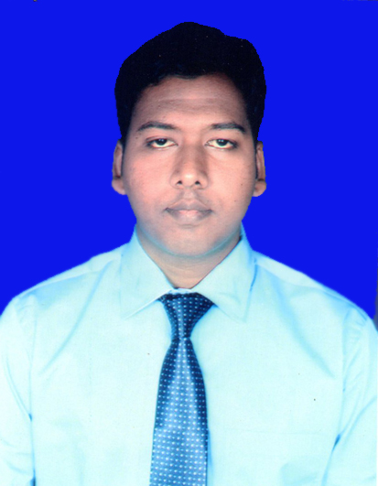
RESUME

Name: SAROJ KUMAR SAHOO
E-Mail id: bputsaroj@gmail.com
Mob: 8455818283
PAN No: FNUPS9678L

CAREER OBJECTIVES

- To acquire a position more suited to my skills and capabilities.

- Endeavor to make the best use of my skill sets / potential to benefit the organization.

ACADEMIC QUALIFICATION

Examination passed | Board / University Institution | School/ College Name | Year of Passing | % of Marks
10TH | BSE | SSD Bidyapitha,  Patapur, Cuttack | 2006 | 86
+2  (Science) | CHSE | Banki College, Banki | 2008 | 70
B.Tech  (ETC branch) | BPUT | JIET, Cuttack | 2012 | 67

ACADEMIC PROJECT
Title- Zigbee Based Smart Helmet

SIGNIFICANT ACHIEVEMENT
I had got 1st prize in 10th for securing highest marks among all the students of our school.

PERSONAL DETAILS

Name : Saroj Kumar Sahoo
Father’s Name : Paramananda Sahoo
Permanent Address : At- Patapur
Po- Patapur
Via- Banki
Dist- Cuttack, Odisha
Pincode-754008
Date of Birth : 01 July 1991
Language Known : Odia, English & Hindi

HOBBIES
Writing Odia Poems, Listening music & Playing Cricket

DECLARATION

I do hereby declare that all the statements given above are true and correct

to the best of my knowledge and belief.

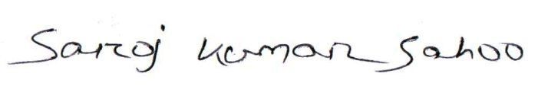
Date: 12.05.2015

Place: Bhubaneswar Signature of the Candidate

